I. Functional Requirements
Student Attendance Management System
The Student Attendance Management System is a console-based (command-line) program developed in Python.
The purpose of the system is to help lecturers record student attendance and allow students to review their own attendance results.

1. User Account Management and Authentication
Account Registration:
- Both students and lecturers can register for a new account within the program.
- Registration information includes: full name, user ID, account type (Student or Lecturer), class, and password.
- The system checks for duplicate user IDs before saving the registration data.
Login:
- Users log in using their ID and password.
- After successful login, the system automatically identifies the user’s role (Lecturer or Student) and displays the corresponding functions.
Update Personal Information:
- Users can modify certain personal information such as password, phone number, or address.
- The user ID and account type cannot be changed.

2. Information and Notification Viewing
View General Announcements:
- Both students and lecturers can view general announcements entered by the system or lecturers.
- Announcements are displayed in chronological order, with the most recent appearing first.

3. Attendance Activities
For Students:
- View Class Schedule:
Students can view their class schedules for the upcoming month.
- Mark Attendance:
Students log into the system, select the correct class session in progress, and enter the attendance code provided by the lecturer.
- View Attendance Results:
Students can review their attendance history, including the date, course, and attendance status (Present / Absent / Late / Excused).
For Lecturers:
- Create Class Session:
Lecturers enter session details including date, period, and course name.
After creation, the system automatically generates a random 5-digit attendance code, which the lecturer provides to students for attendance.
- View Class Attendance Results:
Displays a list of students and their attendance status for each class session.
- Manage Attendance Records:
Lecturers can edit the attendance results of individual students to reflect special circumstances.

4. Administration
User Management:
- View the complete list of user accounts.
- Delete or modify user information if necessary.
Statistics:
- View the total number of students, lecturers, classes, and overall attendance rate.

II. Non-Functional Requirements
Usability
- The command-line (console) interface is simple, user-friendly, and easy to operate.
- Menus are clearly displayed with step-by-step instructions (e.g., Login, Attendance, View Results, etc.).
- No complex installation is required; users can simply run the Python file to start the system.
Reliability
- The system ensures stable operation in an offline environment.
- All data (users, class sessions, attendance records) are stored in .txt or .csv files.
- An automatic backup mechanism is implemented each time data is written to prevent information loss due to system errors.
Performance
- The program can handle dozens of classes and hundreds of attendance records simultaneously without slowdown.
- The response time for each operation (login, search, attendance) is less than 1 second.
- Data size is compact, and file read/write operations are optimized using the csv or json modules.
Supportability
- The source code is clearly structured and divided into modules (user.py, class.py, attendance.py, main.py).
Security
- User passwords are encrypted using the hashlib library.
- Each student can only mark attendance using their own account.
- A 5-digit attendance code is randomly generated for each class session and is only valid for a specific time period.
- Lecturers have permission to edit attendance records, while students can only view their own results.
Design Constraints
- The system is built using Python 3.x.
- Console-based interface (CLI) – no web interface required.
- Data is stored in .txt or .csv files.
- Only standard Python libraries are used.

III. Data Flow Diagram
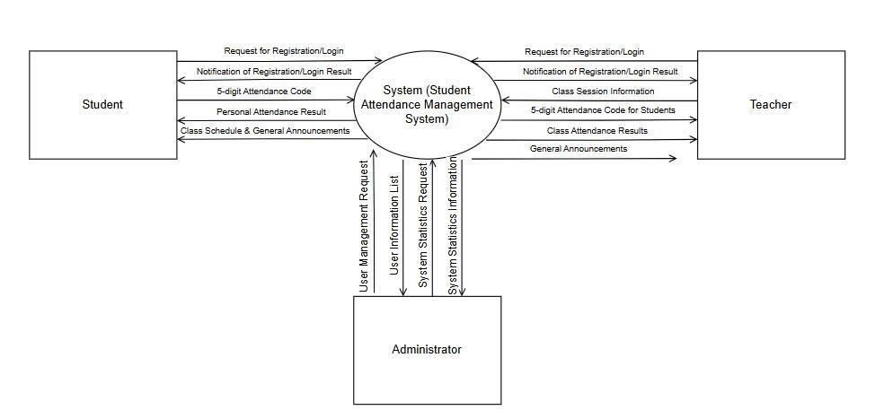

IV. Use-Case Diagram and Use-Case Descriptions

1. Use Case Diagram
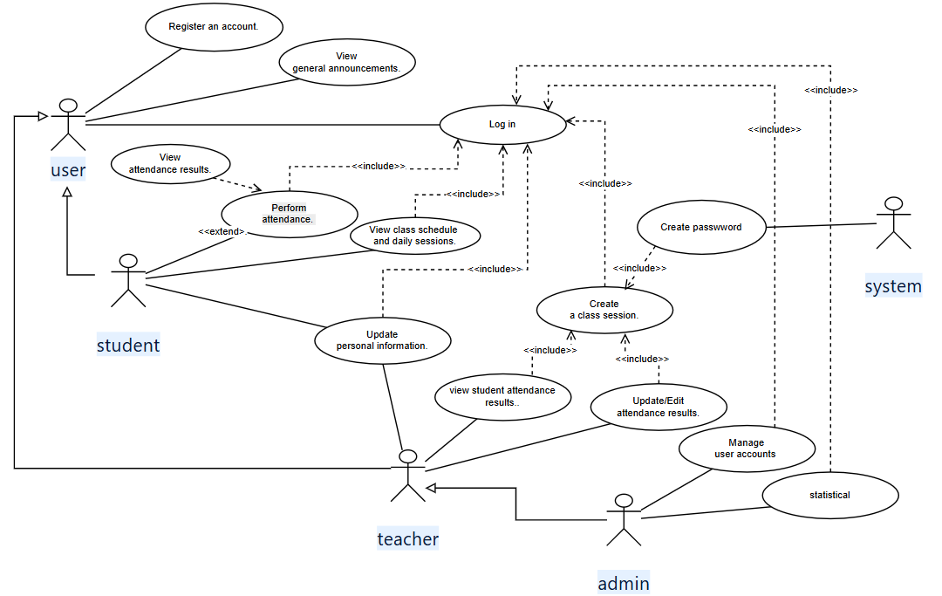

1.1. ACTOR LIST
No. | Actor Name | Role Description
1 | User | General system user who can register, log in, and view announcements.
2 | Student | A student who can view class schedules, perform attendance, and review attendance history.
3 | Teacher | A lecturer who can create class sessions, manage student attendance, and update attendance results.
4 | Admin | The system administrator who manages all user accounts and views statistics.
5 | System | The automated part of the system that generates passwords for new accounts.

1.2. USE CASE LIST
UC ID | Use Case Name | Description
UC01 | Register Account | Allows users (students/teachers) to create a new account in the system.
UC02 | Log In | Enables users to log in to the system with valid credentials.
UC03 | Update Personal Information | Allows users to update their personal information.
UC04 | View General Announcements | Displays system or teacher announcements.
UC05 | View Class Schedule and Daily Sessions | Allows students to view their class schedules and daily sessions.
UC06 | Perform Attendance | Allows students to enter an attendance code to mark their attendance.
UC07 | View Attendance Results | Displays the student’s attendance history.
UC08 | Create Class Session | Allows teachers to create new class sessions.
UC09 | View Class Attendance Results | Allows teachers to view attendance results of their class.
UC10 | Update/Edit Attendance Results | Allows teachers to correct or update attendance records.
UC11 | Manage User Accounts | Enables the administrator to manage user accounts.
UC12 | Statistical | Allows the administrator to view attendance and user statistics.
UC13 | Create Password | The system automatically generates passwords for new or reset accounts.

2. UC01 – Register Account
2.1 Summary
This use case allows students or teachers to create a new account in the system. The system validates the uniqueness of the user ID before saving.
2.2 Flow of Events
2.2.1 Main Flow
- The user selects “Register Account”.
- The system requests full name, user ID, account type (Student/Teacher), class, and password.
- The user fills in all required information.
- The system validates the input and checks for duplicate IDs.
- If valid, the system saves the new user record.
- The system displays “Registration successful”.
2.2.2 Alternative Flows
- 3a. If required fields are missing, the system prompts the user to re-enter.
- 4a. If the user ID already exists, the system shows an error and requests a different ID.
2.3 Special Requirements
- Password must have at least 6 characters.
- User ID must be unique.
2.4 System State Before Execution
No account exists for the user.
2.5 System State After Execution
A new user account is successfully created and stored.
2.6 Extension Points
- UC02: Log In (can follow registration).

3. UC02 – Log In
3.1 Summary
Allows users to access the system using their registered ID and password. The system automatically identifies the user’s role.
3.2 Flow of Events
3.2.1 Main Flow
- The user selects “Log In”.
- The system requests ID and password.
- The user inputs credentials and confirms.
- The system verifies credentials.
- If valid, it identifies the user role (Student/Teacher/Admin) and grants access.
3.2.2 Alternative Flows
- 4a. If credentials are invalid → show “Incorrect ID or password”.
- 4b. If account is locked → display a message and deny access.
3.3 Special Requirements
None.
3.4 System State Before Execution
User is not logged in.
3.5 System State After Execution
User is authenticated and logged into their role dashboard.
3.6 Extension Points
None.

4. UC03 – Update Personal Information
4.1 Summary
Allows logged-in users to update personal details such as password, phone number, or address.
4.2 Flow of Events
4.2.1 Main Flow
- The user selects “Update Personal Information”.
- The system displays current user information.
- The user edits and submits changes.
- The system validates the input.
- The system updates and confirms success.
4.2.2 Alternative Flows
- 4a. If invalid data format → display error and prompt re-entry.
4.3 Special Requirements
- User ID and account type cannot be changed.
- Data format must be validated.
4.4 System State Before Execution
User is logged in.
4.5 System State After Execution
Personal information is successfully updated.
4.6 Extension Points
None.

5. UC04 – View General Announcements
5.1 Summary
Allows users to view general announcements posted by the system or teachers.
5.2 Flow of Events
5.2.1 Main Flow
- The user selects “View Announcements”.
- The system displays a list of announcements sorted by time (latest first).
- The user selects one to view details.
- The system shows the announcement content.
5.2.2 Alternative Flows
- 2a. If there are no announcements, display “No new announcements”.
5.3 Special Requirements
- Announcements should be sorted newest to oldest.
- Display title and posting date clearly.
5.4 System State Before Execution
User is logged in.
5.5 System State After Execution
Announcements are displayed successfully.
5.6 Extension Points
None.

6. UC05 – View Class Schedule and Daily Sessions
6.1 Summary
Students can view their class schedules and upcoming sessions.
6.2 Flow of Events
6.2.1 Main Flow
- The student selects “View Schedule”.
- The system displays all upcoming sessions for the week or month.
- The student can view details such as course, date, and period.
6.2.2 Alternative Flows
- 2a. If no schedule exists → display “No data available”.
6.3 Special Requirements
- Schedule must be sorted chronologically.
6.4 System State Before Execution
Student is logged in.
6.5 System State After Execution
Class schedule is displayed.
6.6 Extension Points
None.

7. UC06 – Perform Attendance
7.1 Summary
Allows students to mark attendance by entering the attendance code provided by the teacher.
7.2 Flow of Events
7.2.1 Main Flow
- The student selects “Perform Attendance”.
- The system asks for the attendance code.
- The student enters the code.
- The system validates and records the attendance.
- The system confirms “Attendance successful”.
7.2.2 Alternative Flows
- 4a. If code is invalid or expired → display an error message.
7.3 Special Requirements
- The attendance code must match the session and be time-limited.
7.4 System State Before Execution
A class session exists and attendance is open.
7.5 System State After Execution
Attendance is recorded in the system.
7.6 Extension Points
- UC10: Teacher can later edit attendance if needed.

8. UC07 – View Attendance Results (Student)
8.1 Summary
Allows students to view their attendance history with session details.
8.2 Flow of Events
8.2.1 Main Flow
- The student selects “View Attendance Results”.
- The system displays the list of sessions and statuses (Present, Absent, Late, Excused).
8.2.2 Alternative Flows
- 2a. If no data exists → display “No results found”.
8.3 Special Requirements
- Students can only view their own records.
8.4 System State Before Execution
Student is logged in.
8.5 System State After Execution
Attendance records are displayed.
8.6 Extension Points
None.

9. UC08 – Create Class Session
9.1 Summary
Allows teachers to create a new class session for attendance tracking.
9.2 Flow of Events
9.2.1 Main Flow
- The teacher selects “Create Class Session”.
- The system requests session information (subject, date, period).
- The teacher enters data and confirms.
- The system generates a 5-digit random attendance code.
- The session and code are saved and displayed.
9.2.2 Alternative Flows
- 3a. If missing data → system requests completion.
9.3 Special Requirements
- Attendance codes must be unique and random.
9.4 System State Before Execution
Teacher is logged in.
9.5 System State After Execution
The session is saved successfully.
9.6 Extension Points
- UC06: Students use the code to perform attendance.

10. UC09 – View Class Attendance Results (Teacher)
10.1 Summary
Allows teachers to view attendance results for each class session.
10.2 Flow of Events
10.2.1 Main Flow
- The teacher selects “View Class Attendance Results”.
- The system shows a list of students with their attendance statuses.
10.2.2 Alternative Flows
- 2a. If no data available → display “No attendance results”.
10.3 Special Requirements
- Results must correspond to the selected class session.
10.4 System State Before Execution
A session has been created and attendance recorded.
10.5 System State After Execution
Teacher can view all attendance results.
10.6 Extension Points
- UC10: Edit Attendance Results.

11. UC10 – Update/Edit Attendance Results
11.1 Summary
Allows teachers to update student attendance records in special cases.
11.2 Flow of Events
11.2.1 Main Flow
- The teacher selects “Edit Attendance Results”.
- The system displays students and current statuses.
- The teacher edits a record.
- The system updates the database and confirms success.
11.2.2 Alternative Flows
- 3a. If the teacher lacks permission → access denied.
11.3 Special Requirements
- Only the assigned teacher can edit their own class records.
11.4 System State Before Execution
Teacher is logged in and has access.
11.5 System State After Execution
Attendance record is updated.
11.6 Extension Points
None.

12. UC11 – Manage User Accounts (Admin)
12.1 Summary
Allows administrators to manage user accounts in the system.
12.2 Flow of Events
12.2.1 Main Flow
- The admin selects “Manage User Accounts”.
- The system displays the user list.
- The admin performs actions (Add/Edit/Delete).
- The system updates and confirms success.
12.2.2 Alternative Flows
- Invalid data or duplicate user ID → system rejects the action.
12.3 Special Requirements
- Only admins can perform this function.
12.4 System State Before Execution
Admin is logged in.
12.5 System State After Execution
User database is updated.
12.6 Extension Points
None.

13. UC12 – Statistical (Admin)
13.1 Summary
Allows the administrator to view system-wide statistics such as attendance rates and user totals.
13.2 Flow of Events
13.2.1 Main Flow
- The admin selects “Statistics”.
- The system calculates and displays summary data.
13.2.2 Alternative Flows
- If no data → display “No statistics available”.
13.3 Special Requirements
- Data must be displayed in real time.
13.4 System State Before Execution
Admin is logged in.
13.5 System State After Execution
Statistics are displayed.
13.6 Extension Points
None.

14. UC13 – Create Password (System)
14.1 Summary
The system automatically generates a password when creating or resetting a user account.
14.2 Flow of Events
14.2.1 Main Flow
- When a new account is created, the system generates a random password.
- The system encrypts and stores the password.
- The user uses this password to log in.
14.2.2 Alternative Flows
None.
14.3 Special Requirements
- Password length: 6–8 characters, alphanumeric.
14.4 System State Before Execution
A new account is created or reset request triggered.
14.5 System State After Execution
The user has a valid password.
14.6 Extension Points
- UC02: Log In using the new password.

V. Class Diagram
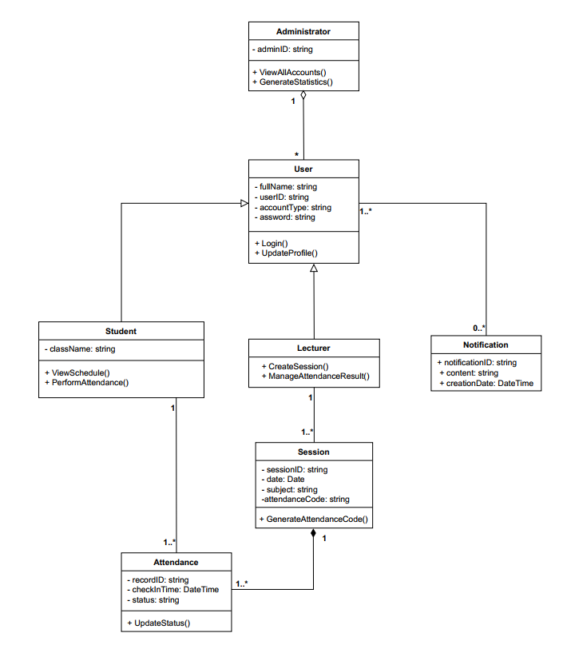

VI. Data Model
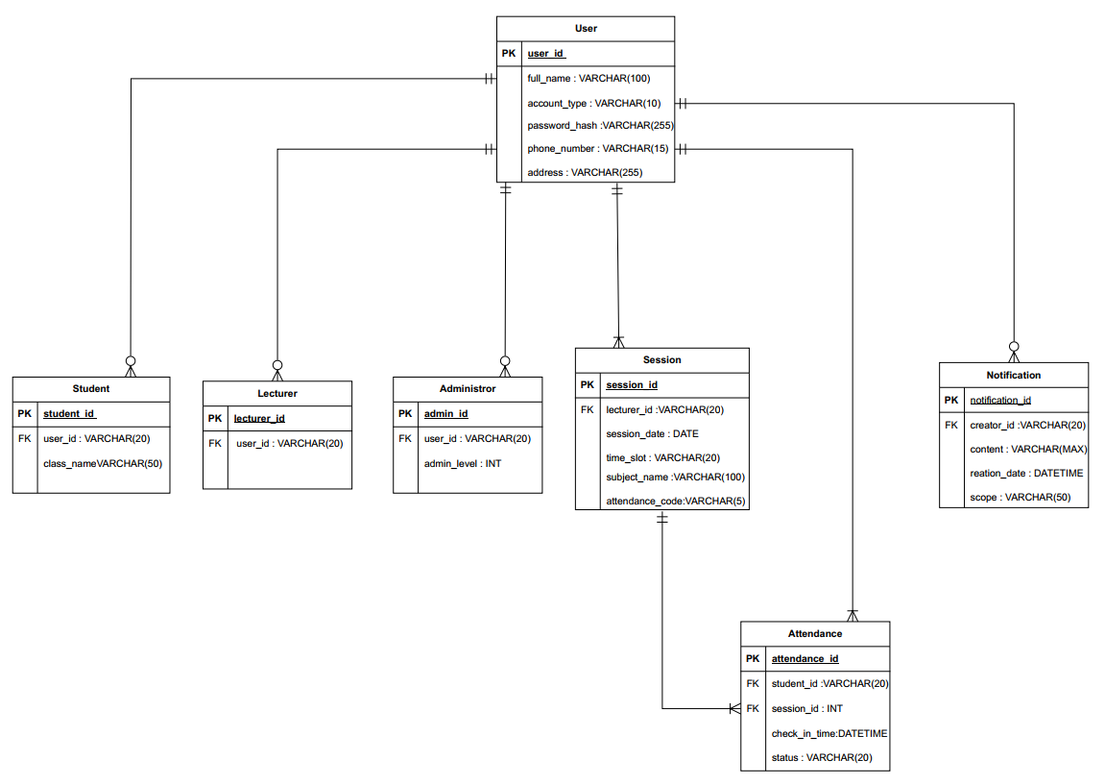

VII. Interface Design Description

1. Introduction
The interface design describes how users interact with the Student Attendance Management System through a command-line interface (console).
Although the system does not include a graphical interface, the User Interface (UI) must still be clear, understandable, user-friendly, and consistent.
It should enable students, lecturers, and administrators to operate the system easily without requiring extensive training.

2. Interface Design Objectives
- Ensure usability: Users should be able to understand and operate the system based solely on on-screen instructions.
- Reduce cognitive load: The system provides step-by-step guidance, eliminating the need to memorize complex commands.
- Maintain consistency across screens: Uniform input methods, error messages, and confirmation styles.
- User-centered design: Every action can be canceled, reverted, or confirmed before saving.
- Support three user groups: Students, lecturers, and administrators – each with its own functional menu.

3. User Analysis
- Students: Possess basic computer skills; interact mainly through keyboard input. Require clear instructions and easy-to-understand messages.
- Lecturers: More experienced users who need fast operations for creating sessions, recording attendance, and editing results.
- Administrators: Familiar with management systems; need interfaces that display lists, statistics, and confirmation prompts for edit/delete actions.
The main interface language is Vietnamese, and information is displayed as numbered menus or character-based commands (1–9 or Y/N).

4. Task Analysis
User Group | Main Tasks | Description
Student | Log in, view schedule, enter attendance code, view results | The system displays menus and guides users step by step.
Lecturer | Log in, create class session, view class results, edit attendance | The system requests session information and confirmation before saving.
Administrator | Manage user accounts, view statistics, edit/delete users | All operations require confirmation before execution.
System (Automatic) | Generate attendance codes, display notifications, validate data | The system responds with clear and consistent messages.

5. Display Content Analysis
- Information is presented in short text lines with clear labels (e.g., “Enter ID:”, “Select function:”).
- Main menus are displayed as numbered lists, for example:
STUDENT ATTENDANCE SYSTEM
1. Register Account
2. Log In
3. Exit
Select a function (1-3):
- Error and confirmation messages follow a consistent format:
  - Error: [ERROR] User ID already exists!
  - Success: [SUCCESS] Information updated successfully.
- Search or report results (such as schedules or attendance records) are shown in tabular text format, for example:
Date Course Status
01/11/2025 Advanced Math Present
03/11/2025 Basic Informatics Absent

6. Interaction Design
- Users interact through the keyboard by entering numbers, letters, or pressing Enter to confirm.
- Each action provides options to go back (Back) or exit (Exit) for full control.
- Critical operations (delete, edit) require confirmation, e.g.,
“Are you sure you want to delete? (Y/N)”
- The system provides brief instructions at each step, for example:
“Enter attendance code (5 digits provided by lecturer):”

7. Interface Structure Design
The interface is organized in a hierarchical menu structure, including:
- Main Menu
  - Register Account
  - Log In
  - Exit
- Student Menu
  - View Schedule
  - Mark Attendance (Enter Code)
  - View Attendance Results
  - Log Out
- Lecturer Menu
  - Create Class Session
  - View Class Attendance Results
  - Edit Attendance Results
  - Log Out
- Administrator Menu
  - Manage Users
  - View System Statistics
  - Log Out

8. Design Issues
- Response Time: The system must display responses within <1 second after each action.
- Error Handling: All input errors are accompanied by clear correction instructions, and no data is lost.
- Help Support: Short guidance messages (e.g., “Enter the number corresponding to your choice”) are provided.
- Internationalization (I18n): Default interface language is Vietnamese, but the system can be extended to support English.

9. Interface Evaluation
The interface is evaluated through:
- User Testing: Real students and lecturers perform typical tasks.
- Usability Measurement: Number of input errors, task completion time, and ease of use.
- User Feedback: Collect opinions on clarity, simplicity, and logical menu structure.

10. Conclusion
The console-based interface of the Student Attendance Management System ensures:
- Friendliness, ease of learning, and ease of use.
- Suitability for users without advanced IT skills.
- Clear structure, fast responses, and consistent interaction.

